Sri Lanka Institute of Information

Technology

**Introduction to Cyber Security - IE2022**

Lab Submission 07

**IT22151056**

**De Silva K.R.K.D**

**Group – WD.CS 01.02**



Task 01

encryption and Decryption using different ciphers and modes

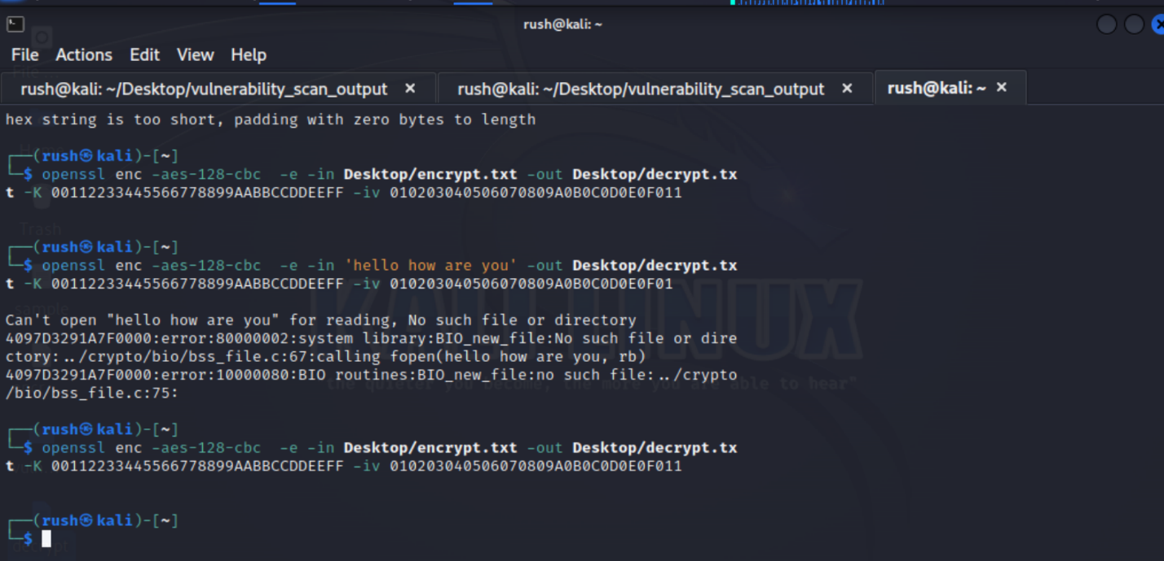**1.Encrypt using cbc mode.**

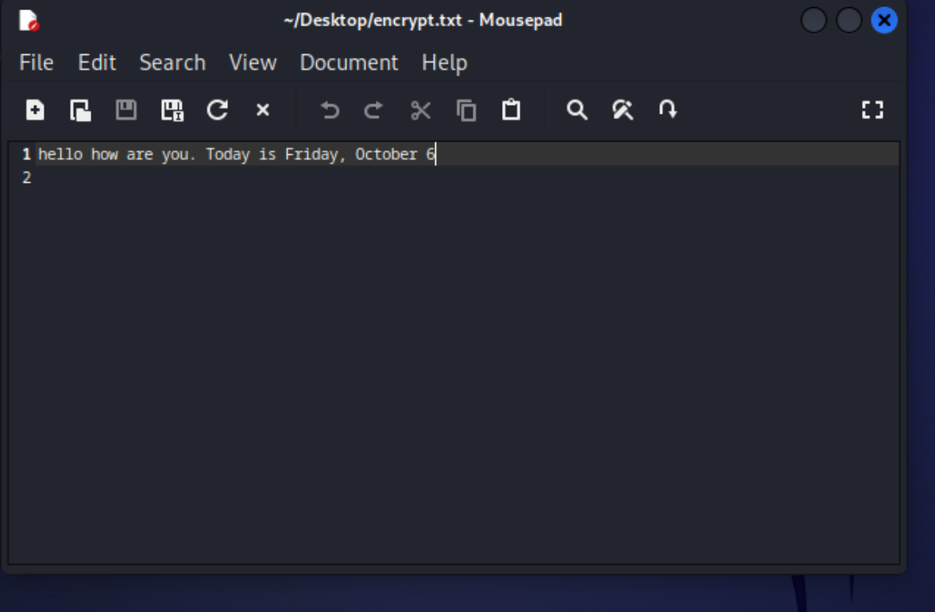Plaintext file

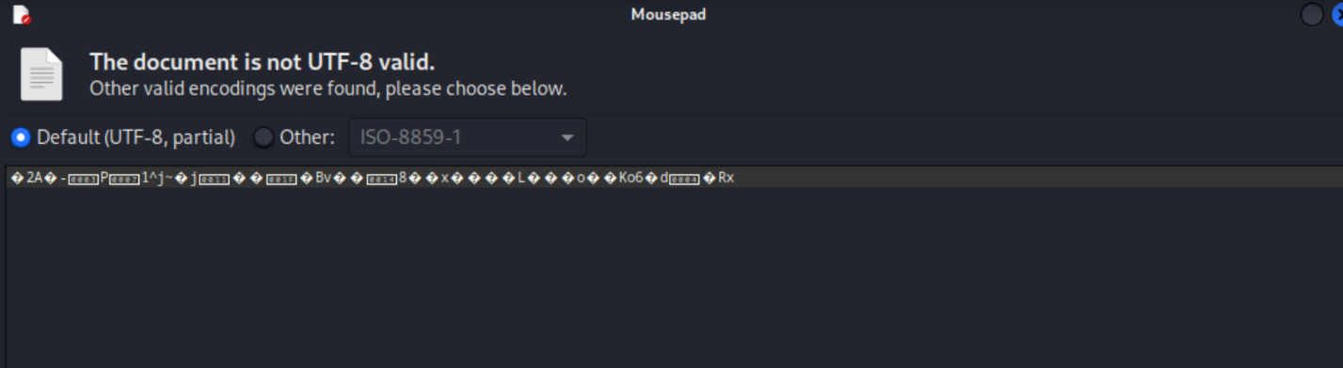Decrypted file

**2.Encrypt using CFB mode**



Plaintext file



Encrypted File

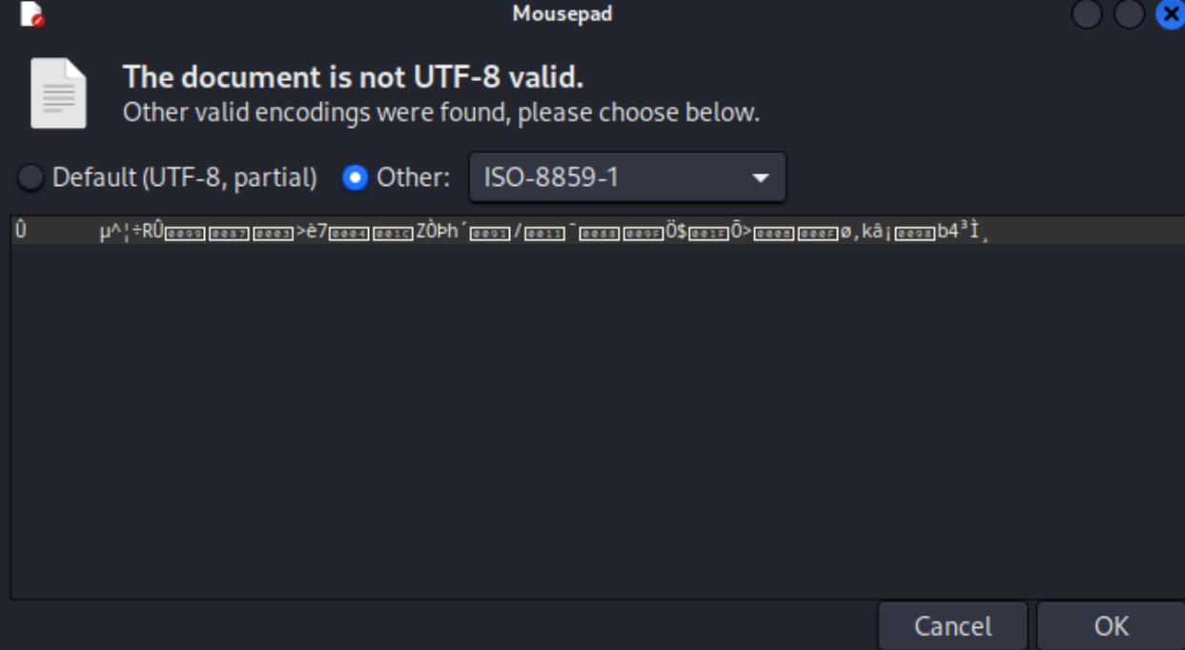

**3.Encrypted Using CTR mode**

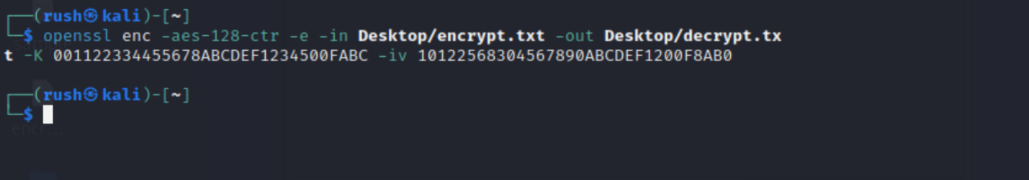

Plaintext file



Encrypted File

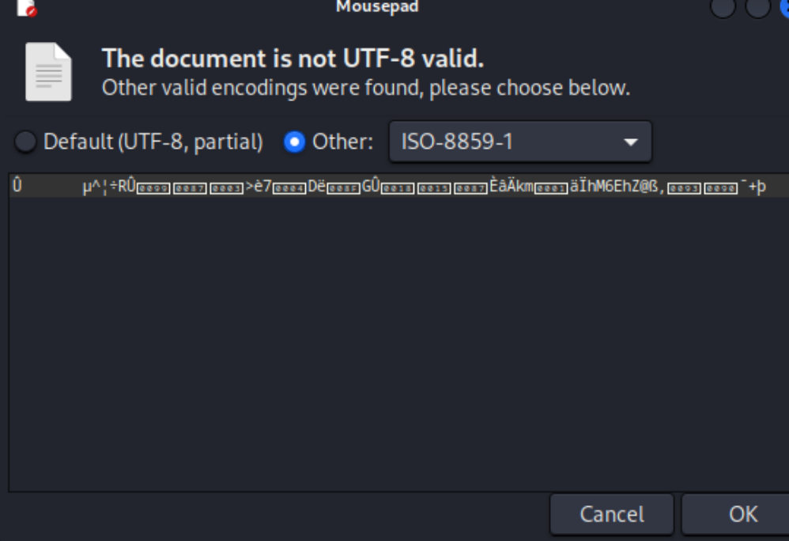

Here, when different modes are used, even if the same key and iv value are used, different decryption values are obtained.